runC

Malicious container escape

CVE-2019-5736

K. G .Sasindu Shehan Kaushalya

IT19172088

Abstract:

This report is regarding the runC malicious container escape vulnerability (CVE-2019-5736) which was found in 2019 February. This was originally founded by Adam Iwaniuk and Borys Poplawski. In this report it is explained what this vulnerability is, the reasons for this vulnerability to occur, how the attacker exploits them and the conclusion regarding this vulnerability with how to prevent from this CVE-2019-5736.

Introduction:

RunC or the container runtime was originally designed and developed as a part of docker and lately it was extracted out as a separate open source tool and library.

Now this is used by docker to implement functons like creating and management of images and handle tasks related to running containers. It has been figured out that there’s a vulnerability in these containers that hackers can exploit and gain root privileges and modify and delete compromised machines data.

A detailed information regarding this vulnerability is given follow in the report regarding CVE-2019-5736.

Procfs:

To gain knowledge regarding runC vulnerability, understanding procfs basics is crucial.

Proc filesystem is a virtual filesystem (that it does not exist on hard drive, kernel makes this in memory ) in Linux that gives information mainly about processes, classically mounted to /proc.

This is an interface to system’s data, which is been exposed by the kernel by way of a filesystem. Individually processes have their own directory in procfs in

/proc/[pid]:

In the procfs filesystem /proc /self is the link to the directory of the current running process, and in this case of the vulnerability the relevant processes are

/proc /self /exe :- symbolic link to executable files in running process.

/proc /self /fd :- directory having the file descriptors open by the running process.

runC :

This is also known as the container runtime, which is the de-facto implementation of the runtime specification. runC allows a user to create a container entirely with just a single path where the root file system and configuration file that defines the container to look like in low level.

The key feature in running a container is user namespaces. It’s a very specific namespace that allows user to pretend that an unprivileged user is root and has privileges.

runC is used by high level container runtimes such as docker to implement functions such as creation of images and management of images, and to handle tasks related to running containers.

The vulnerability:

The runC vulnerability allows a malicious container to overwrite the host runc binary and accordingly acquire root-level code execution on the host. The level of user interaction is being able to run any command as root within a container in either:

1. Generating a new container using an attacker – controlled image.
2. Attaching (docker exec) into a previously existing container which the attacker had previous write access to.

When this binary is running, it must already be confined and restricted inside the container, or it can jeopardize the host

So, in order to achieve that task, runC creates a ‘runC init’ subprocess, which places all needed restrictions on itself (entering namespace or setting up namespace) and effectively places itself in the container.

Then, the runC init sub process, now in the container, calls the execve syscall to overwrite itself with the user requested binary.

So, attacker can trick runC into executing itself by asking it to run

/proc /self /exe

Which is a symbolic link to the runC binary on the host. Next, the attacker with root privileges in the container can then use (not host in the container)

/proc /[runc-pid] /exe

as a reference to the runC binary on the host and overwrite it.

So, when the next time runC is executed, the attacker will achieve code execution on the host. Since the runC is normally run as root (docker daemon), the attacker will gain root access as the host.

Exploitation of the vulnerability :

The exploitation is done by running a malicious image which allows container escape. When the malicious image is running, it exploits a defect to overwrite the runC binary on the host and thereby allowing unlimited control of both the host itself and any other container running on it. This affects the LVC and LVC patch.

The attack can be made when attaching to running container or when starting a container running the specially crafted image.

For example:

When runC attaches to a container the attacker can trick it into executing itself. This could be done by replacing the target binary inside the container with a custom binary pointing back at the runC binary itself

As an example: if targeted binary was

/bin /bash

This could be replaced with an executable script specifying the interpreter path

#! /proc /self /exe

(Symbolic link created by the kernel for every process which points to the binary that was executed for that process)

As such when

/bin /bash

is executed inside the container, instead the target of

/proc /self /exe

Will be executed (which will point to the runC binary on the host).

The attacker can then proceed to write down to the target of

/proc /self / exe

to try and overwrite the runC binary on the host

However, in general, this will be not successful as the kernel will not permit to be overwritten while runC is executing.

So, to overcome this the attacker can instead open a file descriptor to

/proc /self /exe

using the O_PATH flag, then proceed to reopen the binary as O_WRONLY through

/proc /self /fd

and try to write down, to it in a busy loop from a separate process. Ultimately, it will succeed when the runC binary exits.

After this the runC binary is compromised and can be used to attach to other containers or to the host itself.

An example of codes used to overwrite the host

exploit.c code:

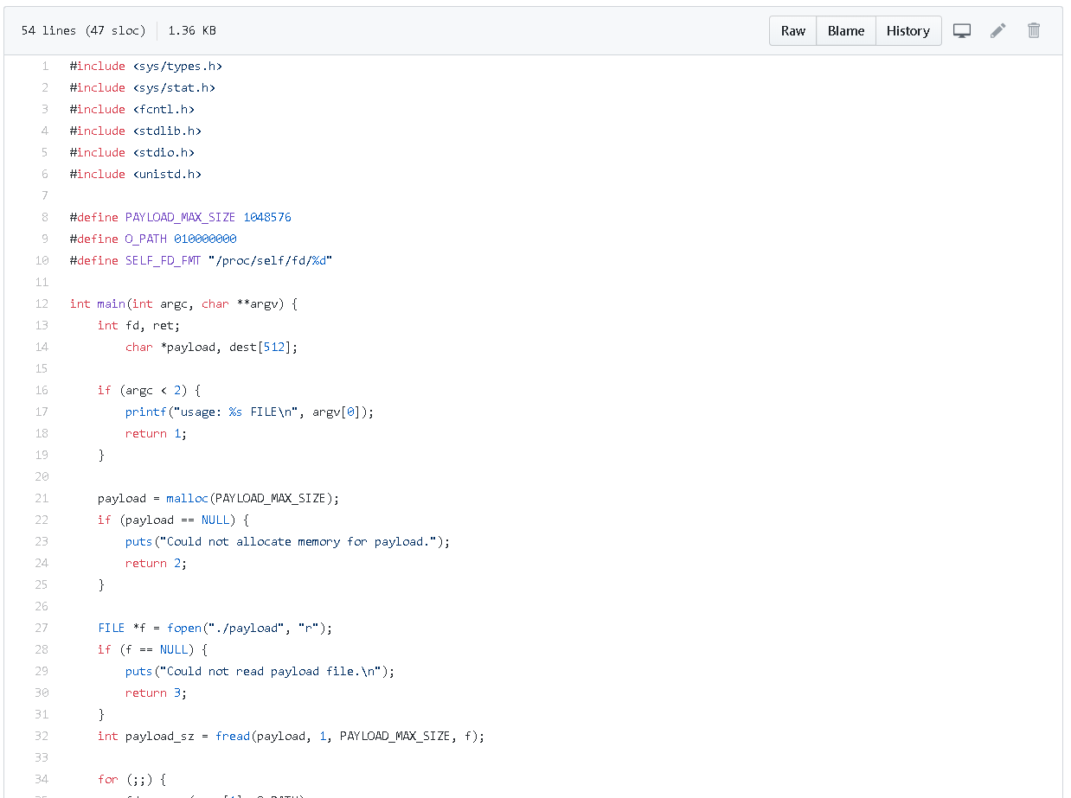

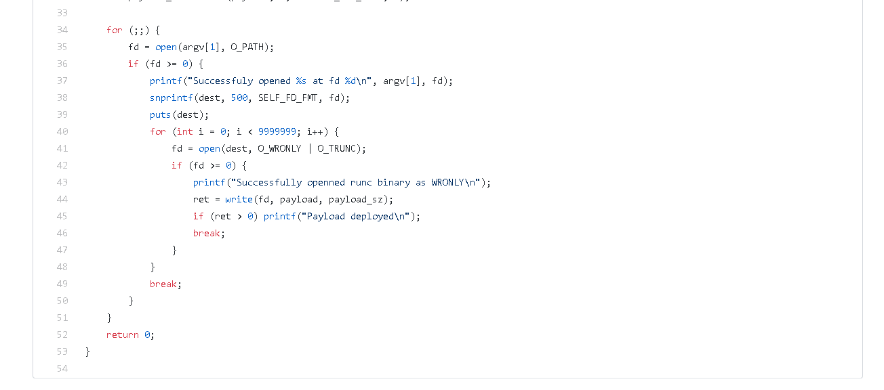

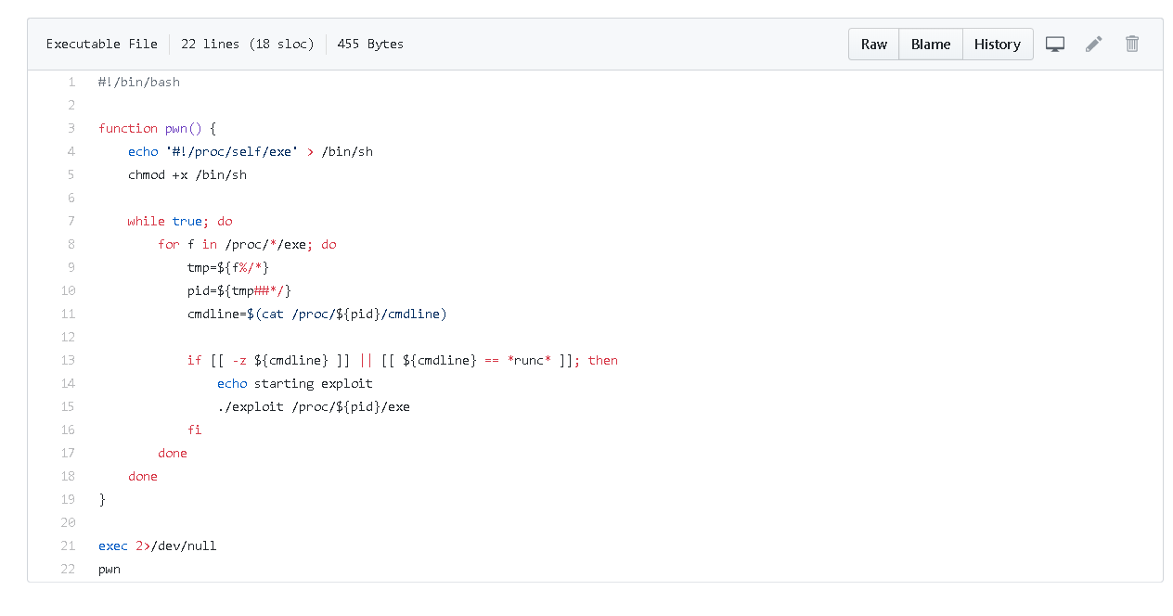pwn.c code:

These codes are the codes used in exploiting the runC vulnerability

In here pwn.sh file overwrites the sh file and make it an executable, the loop go on to do some tasks to be done while true.

This overwrites

/usr /bin /docker

runC binary on the host with payload in exploit file and overwrites

/bin /sh

Demonstration of the exploit:

As I was unable to find and download the docker versions for regarding this vulnerability, I used a previously demonstrated video to explain in my assignment

Below are two terminals. On the left side is the host and on right is the attacker.

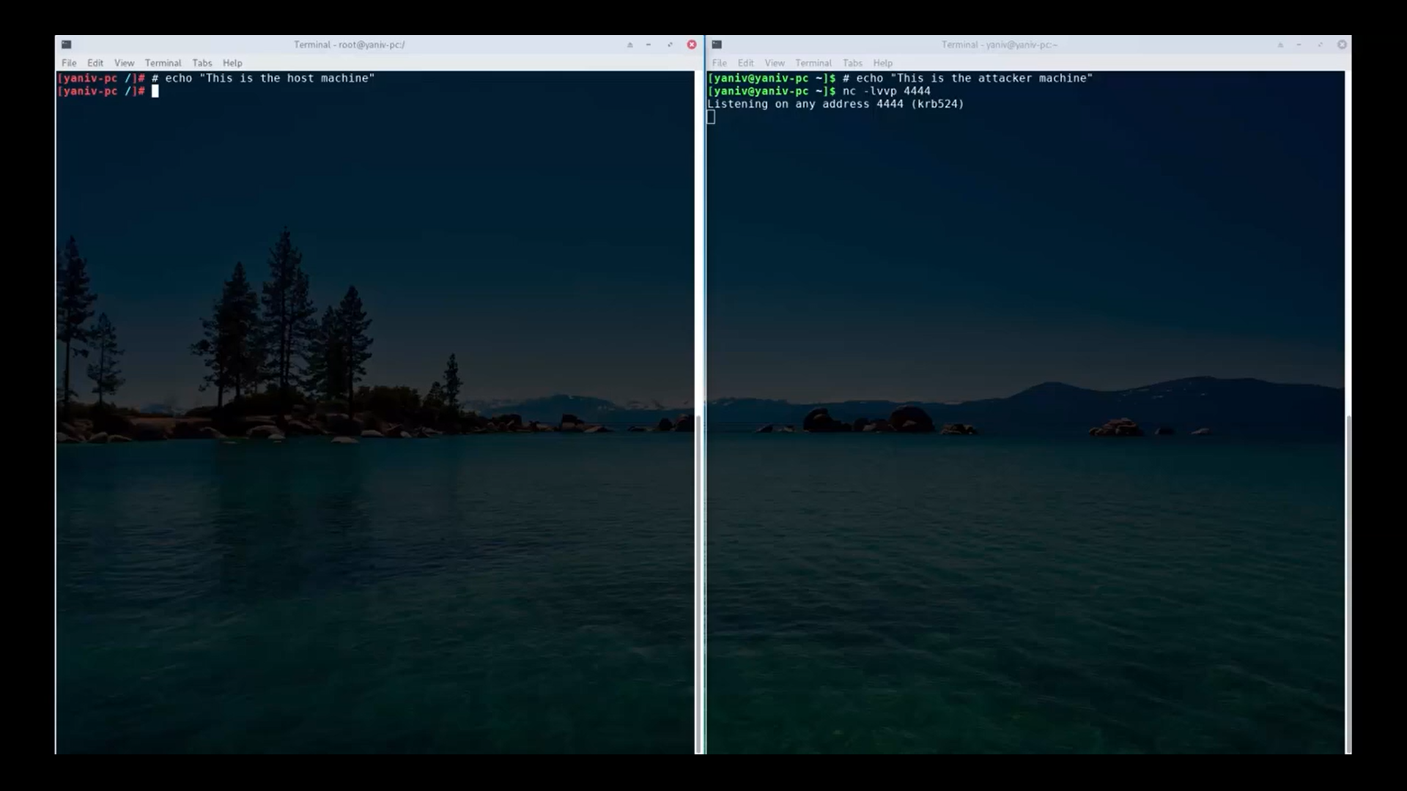

Step 01:

Check the runC library using md5sum command, so at the end we can see the changes in the directory.

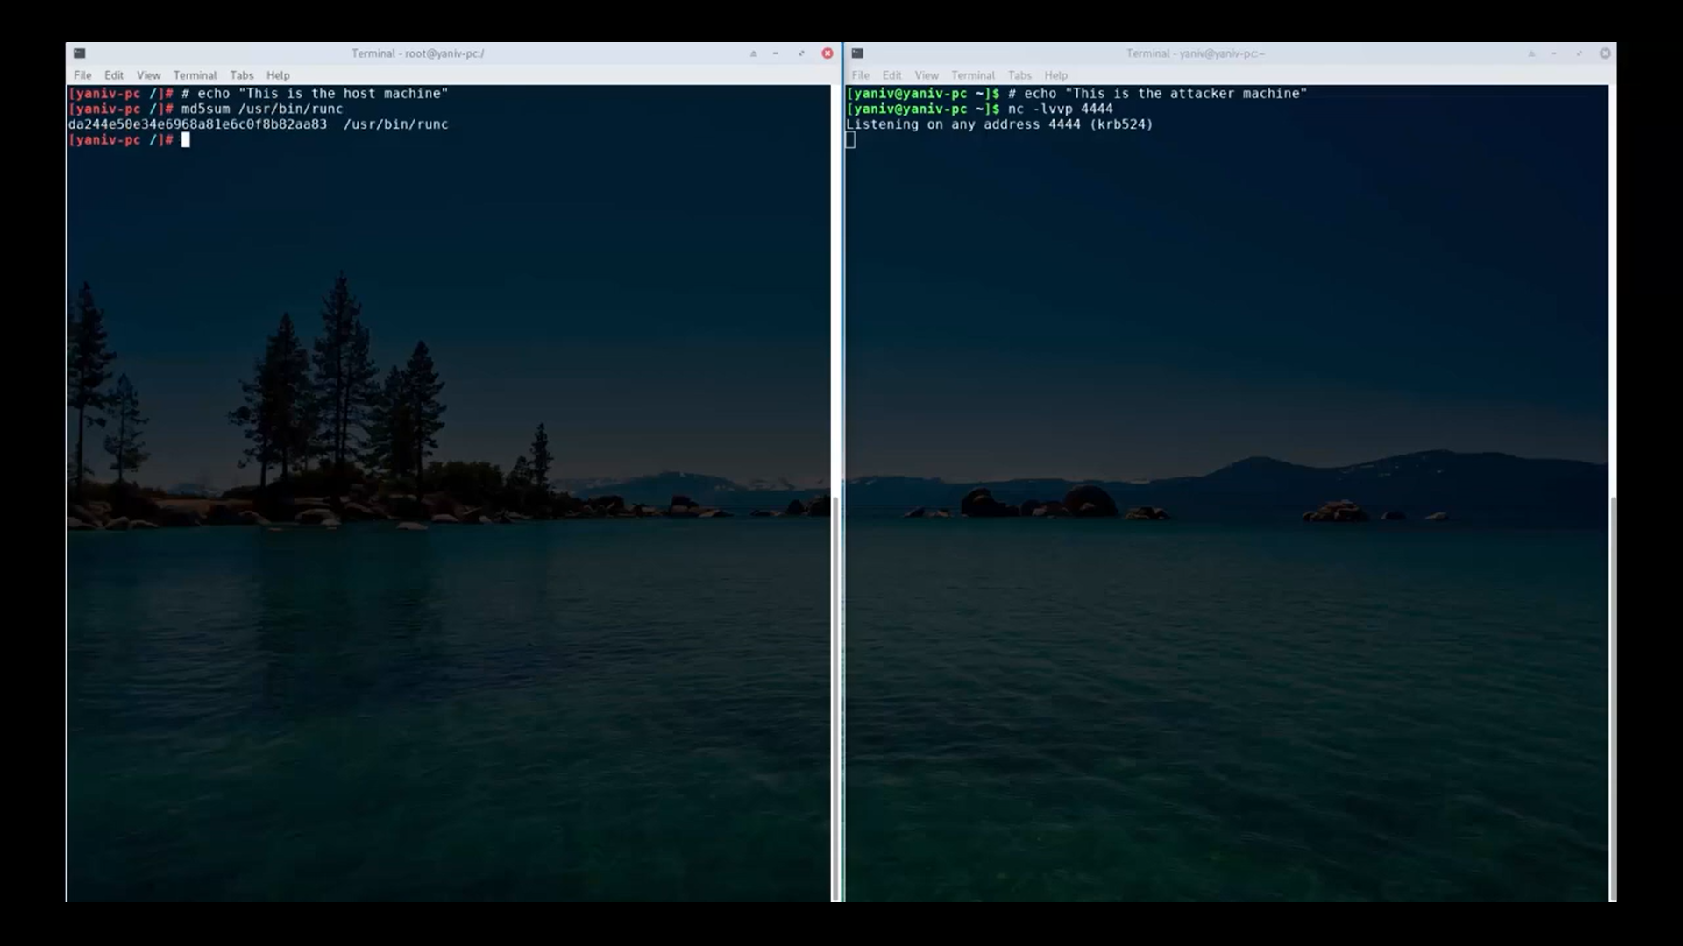

Step 02:

Create a file on the host, in here “secret.txt” is the file.

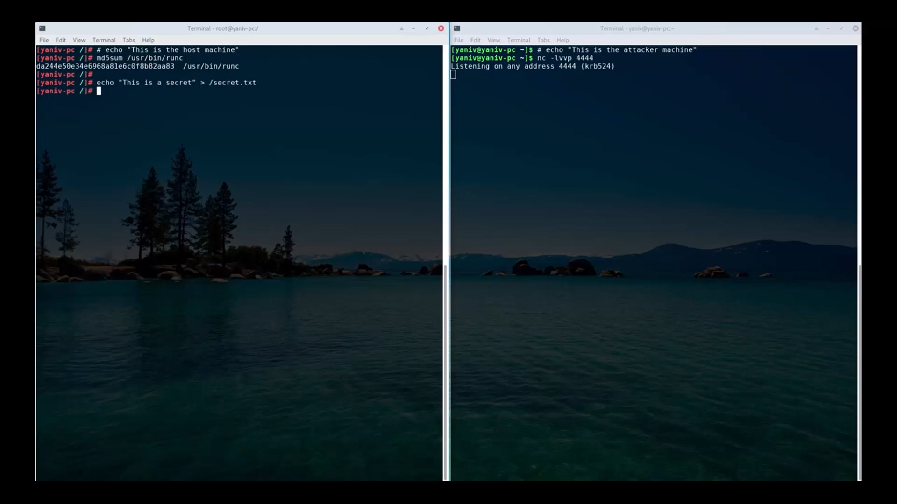

Step 03:

Now run a container with default parameters, a regular container not a privilege container as a regular user, with the default linux user namespace and c groups.

After starting the container, the attacker in the right will get a new connection from the compromised machine. This allows the attacker to control the host machine remotely.

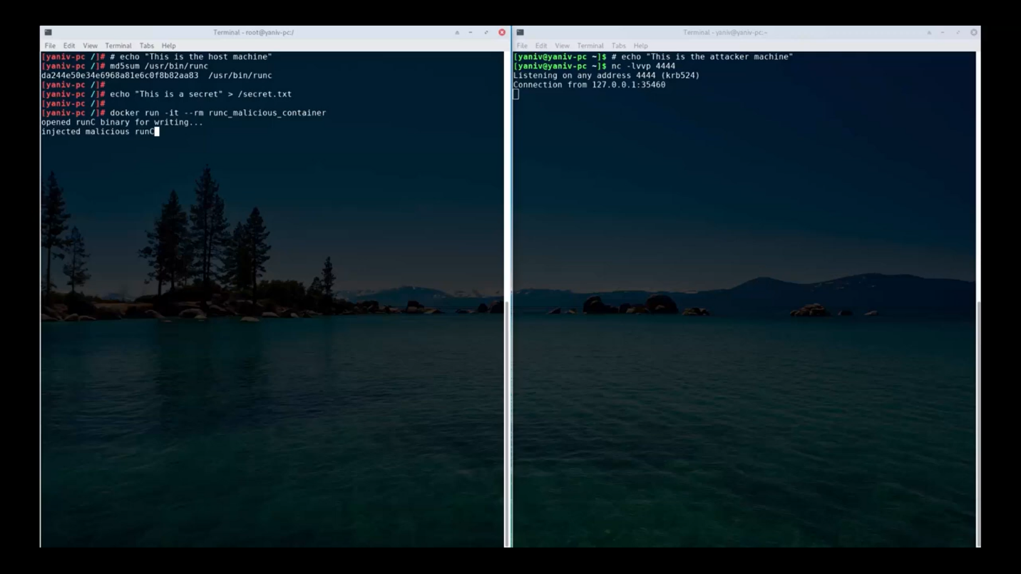

Step 04:

The attacker can use cat command to access the files of the host machine. The attacker opens the secret.txt file as shown here. This shows how the attacker can view the files in the compromised machine without root privileges.

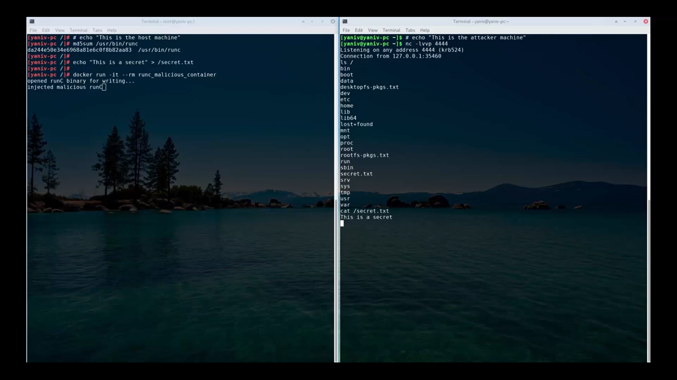

Step 05:

Attacker exits the container. Then we can check the runC by using md5sum command

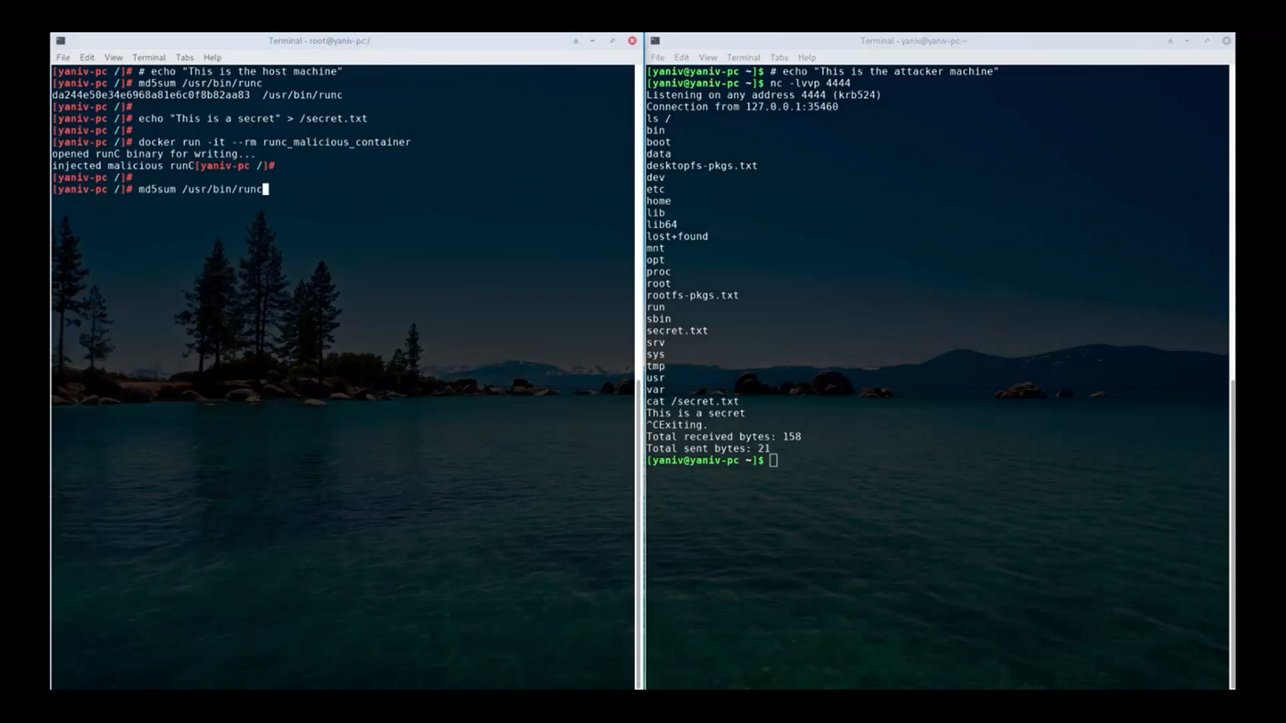

This picture shows how the runC library has changed by the attacker.

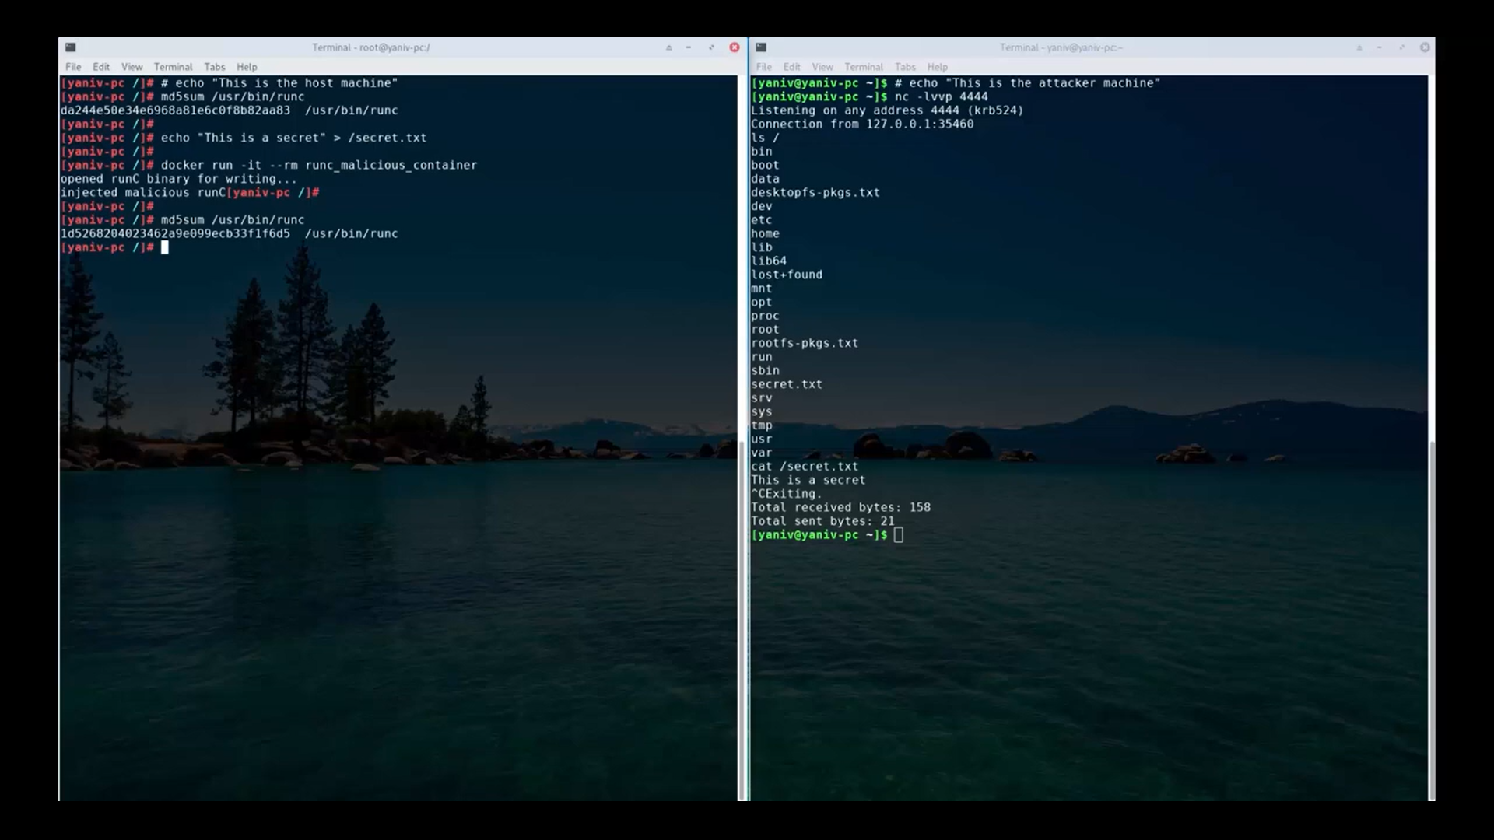

This demonstration shows us how non privileged container on a regular docker machine can influence in changing the user namespace, to break out from the container and compromise the host with full privileges.

Conclusion:

Though exploiting this vulnerability is very difficult, because of the hardness to find the resources to carry on the exploit, this vulnerability takes a major place because it’s ability to gain root privileges.

This vulnerability is now fixed and takes no place in containers. Google, AWS and Red Hat have made official announcements regarding this fix. To fix this we have upgraded their environment with new patches in the system.

Though the environment is upgraded, we should lookout for behavioral changes like access patterns, unexpected connections and other authentication security breaches. A good method for use regarding this vulnerability would be adapting a good firewall to help find, investigate and mediate compromised machines. We can generate two factor authentication, generate secret keys, implement signup flows also to prevent from it, but the most important this to do is to update the working environment, which includes the Linux version, docker version, etc.

References:

<https://www.twistlock.com/2019/02/11/how-to-mitigate-cve-2019-5736-in-runc-and-docker/>

<https://tools.cisco.com/security/center/content/CiscoSecurityAdvisory/cisco-sa-20190215-runc>

<https://access.redhat.com/errata/RHSA-2019:0303>

<https://snyk.io/blog/a-serious-security-flaw-in-runc-can-result-in-root-privilege-escalation-in-docker-and-kubernetes/>

<https://unit42.paloaltonetworks.com/breaking-docker-via-runc-explaining-cve-2019-5736/>

<https://github.com/feexd/pocs/tree/master/CVE-2019-5736>

<https://dzone.com/articles/tips-for-patching-cve-2019-5736>